PATHWAYS IN TECHNOLOGY EARLY COLLEGE HIGHSCHOOL P - T E C H- Mechanical Technology/Engineering
To apply go to nfschools.net website and click on the P-Tech Tab.The application will be available starting Monday March 18
What is P-TECH  P-Tech is a public education reform model focused on college attainment and career readiness. P-TECH schools span grades 9-14 and enable students to earn both a high school diploma and a no-cost, two-year postsecondary degree in a STEM field. Students participate in a range of workplace experiences, including mentorship, worksite visits and paid internships.  SOME FACTS:  P-TECH students can earn their High School Diploma as well as an Associate’s degree in 4-6 years for free!  P-TECH integrates the best elements of high school, college and industry. P-TECH enables students to begin their college and professional lives more quickly and with more support than the typical school-to-work pathway.  P-TECH MET Courses:  3D Technology, Applied Engineering Mechanics, Computer Aided Drafting Design, Engineering Drawing, Hydraulics and Pneumatics, Mechanics of Materials, Principles of Electricity, Robotics, Technical Calculations and Motion, Heat and Light | Why P-TECH  - High School Diploma and a College Degree  (at NO COST) within 4, 5 or 6 years.  - Micro Credential at the end of 12th Grade  - First in line opportunities for jobs with program business partners such as VOSS, OLIN, NYPA, M & T. NFMMC.  - 1-2 Years after High School students can earn their associate’s degree and be prepared to enter the work force upon graduation.  - GET STARTED: Talk to your school counselor about taking your first step!!  - Through grades 9-12 you will experience high school and college classes for college credit, Job Shadowing and Internships  - You will earn an Associates degree from Niagara County Community College at no cost to you.
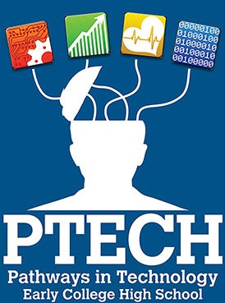 | 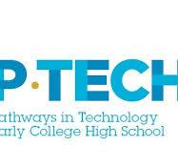

PATHWAYS IN TECHNOLOGY EARLY COLLEGE HIGHSCHOOL
P-TECH- Computer Science/Computer Information Systems
To apply go to nfschools.net website and click on the P-Tech Tab. The application will be available starting Monday March 18
What is P-TECH  P-Tech is a public education reform model focused on college attainment and career readiness. P-TECH schools span grades 9-14 and enable students to earn both a high school diploma and a no-cost, two-year postsecondary degree in a STEM field. Students participate in a range of workplace experiences, including mentorship, worksite visits and paid internships.  SOME FACTS:  P-TECH can earn their High School Diploma and an Associates Degree in 4-6 years for free!  P-TECH integrates the best elements of high school, college and industry. P-TECH enables students to begin their college and professional lives more quickly and with more support than the typical school-to-work pathway.  P-TECH Computer Science Courses:  Computer Science, Computer Systems, Financial Accounting, Managerial Accounting, Writing for STEM, Cybersecurity, Business Commutations, Math, Coding and more. | Why P-TECH  - High School Diploma and a College Degree  (at NO COST) within 4, 5 or 6 years.  - Micro Credential at the end of 12th Grade  - First in line opportunities for jobs with program business partners such as VOSS, Ingram Micro, M & T Hub, Niagara Falls Medical Memorial Center and more.  - 1-2 Years after High School students can earn their associate’s degree and be prepared to enter the work force upon graduation.  - GET STARTED: Talk to your school counselor about taking your first step!!  - Through grades 9-12 you will experience high school and college classes for college credit, Job Shadowing and Internships  - You will earn an Associate’s degree from Niagara County Community College at no cost to you.

